1. Выбрал так же протокол HSRP, добавил R3 в standby с аналогичными настройками

2. Схема сети в Eve-NG
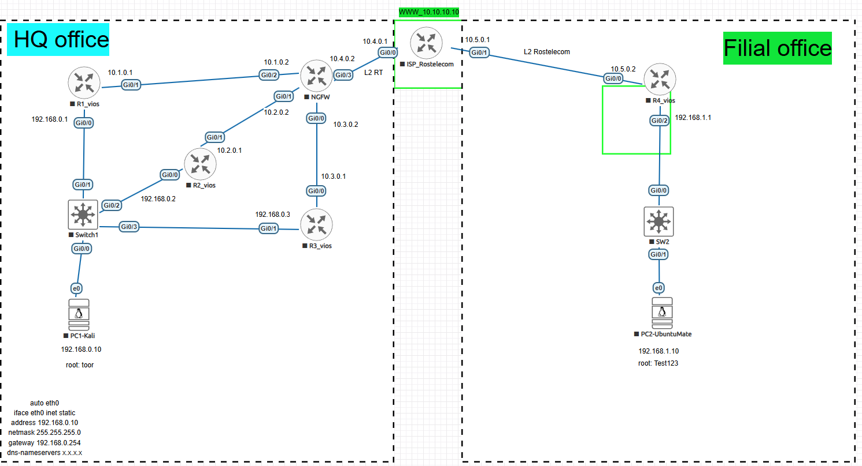

3. Так же выбрал Standby HSRP.
PC HQ office
auto eth0
iface eth0 inet static
address 192.168.0.10
netmask 255.255.255.0
gateway 192.168.0.254

SW1 без настроек
R1
interface GigabitEthernet0/0
ip address 192.168.0.1 255.255.255.0
standby 1 ip 192.168.0.254
standby 1 priority 110
standby 1 preempt
duplex auto
speed auto
media-type rj45
!
interface GigabitEthernet0/1
ip address 10.1.0.1 255.255.255.252
duplex auto
speed auto
media-type rj45

ip route 0.0.0.0 0.0.0.0 10.1.0.2

R2
interface GigabitEthernet0/0
ip address 192.168.0.3 255.255.255.0
standby 1 ip 192.168.0.254
standby 1 priority 105
standby 1 preempt
duplex auto
speed auto
media-type rj45
!
interface GigabitEthernet0/1
ip address 10.3.0.1 255.255.255.252
duplex auto
speed auto
media-type rj45

ip route 0.0.0.0 0.0.0.0 10.2.0.2

R3

interface GigabitEthernet0/0
no ip address
shutdown
duplex auto
speed auto
media-type rj45
!
interface GigabitEthernet0/1
no ip address
standby 1 ip 192.168.0.254
standby 1 priority 101
standby 1 preempt
shutdown
duplex auto
speed auto
media-type rj45

ip route 0.0.0.0 0.0.0.0 10.3.0.2

NGFW

interface GigabitEthernet0/0
ip address 10.3.0.2 255.255.255.252
duplex auto
speed auto
media-type rj45
!
interface GigabitEthernet0/1
ip address 10.2.0.2 255.255.255.252
duplex auto
speed auto
media-type rj45
!
interface GigabitEthernet0/2
ip address 10.1.0.2 255.255.255.252
duplex auto
speed auto
media-type rj45
!
interface GigabitEthernet0/3
ip address 10.4.0.2 255.255.255.252
duplex auto
speed auto
media-type rj45
!
ip forward-protocol nd
!
!
no ip http server
no ip http secure-server
ip route 192.168.0.0 255.255.255.0 10.1.0.1
ip route 192.168.0.0 255.255.255.0 10.2.0.1
ip route 192.168.0.0 255.255.255.0 10.3.0.1
ip route 192.168.1.0 255.255.255.0 10.4.0.1

ISP Rostelecom

interface Loopback0
ip address 10.10.10.10 255.255.255.252
!
interface GigabitEthernet0/0
ip address 10.4.0.1 255.255.255.252
duplex auto
speed auto
media-type rj45
!
interface GigabitEthernet0/1
ip address 10.5.0.1 255.255.255.252
duplex auto
speed auto
media-type rj45
!
ip forward-protocol nd
!
!
no ip http server
no ip http secure-server
ip route 192.168.0.0 255.255.255.0 10.4.0.2
ip route 192.168.1.0 255.255.255.0 10.5.0.2
ip route 0.0.0.0 0.0.0.0 10.10.10.10

R4

interface GigabitEthernet0/0
ip address 10.5.0.2 255.255.255.252
duplex auto
speed auto
media-type rj45
!
interface GigabitEthernet0/2
ip address 192.168.1.1 255.255.255.0
duplex auto
speed auto
media-type rj45
!
ip forward-protocol nd
!
!
no ip http server
no ip http secure-server
ip route 0.0.0.0 0.0.0.0 10.5.0.1

SW без настроек

PC Fillial
auto eth0
iface eth0 inet static
address 192.168.0.10
netmask 255.255.255.0
gateway 192.168.1.1

